**Paul's Place Application Process Analysis**

This report explores key parts of the Culinary Training Program application process: 1. Applications submitted

2. Info session attendance

3. Graduation outcomes

It also includes a multivariate analysis to see how applications and info sessions together influence graduation numbers.

**1. Applications vs Info Session Attendance**

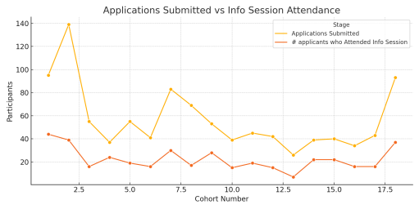

This line chart compares applications and info session attendance across cohorts. They often rise and fall together, showing a close relationship.

**2. Info Sessions and Applications Relationship**

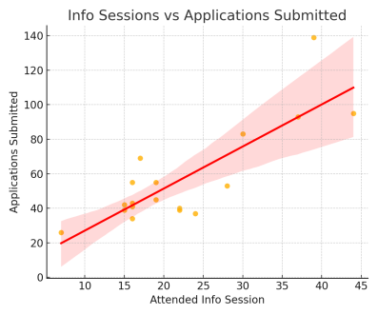

**More people attending info sessions often leads to more submitted applications. This scatter plot shows a strong relationship between the two. 3. Graduation Outcomes by Cohort**

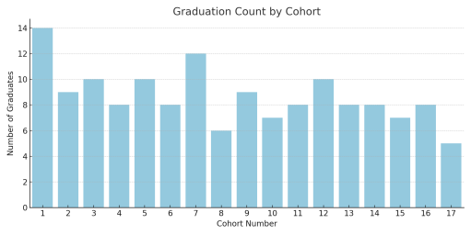**This chart shows how many people graduated from each cohort. It helps**

**identify which groups were more successful.**

**4. Multivariate Analysis: What Drives Graduation?**

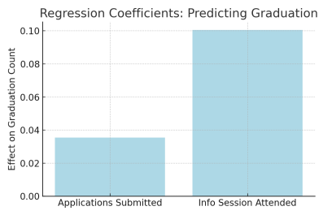

We used a linear regression model to see how applications and info session attendance together predict graduation numbers.

Key Findings:

- Each additional application adds about +0.035 graduates

- Each additional info session attendee adds about +0.10 graduates

- The model's R² value is 0.04, meaning it explains about 4.1% of the variation in graduation counts

This suggests that while these factors are helpful, other things likely influence whether someone completes the program.